NLP Task 2:

COCOA is a system which allows users to generate word-counts and concordances from literary (or other) texts, speeches etc.

The corpus contains more than one billion words of text from eight genres: spoken, fiction, popular magazines, newspapers, academic texts, TV and Movies subtitles, blogs, and other web pages.

Searching a word

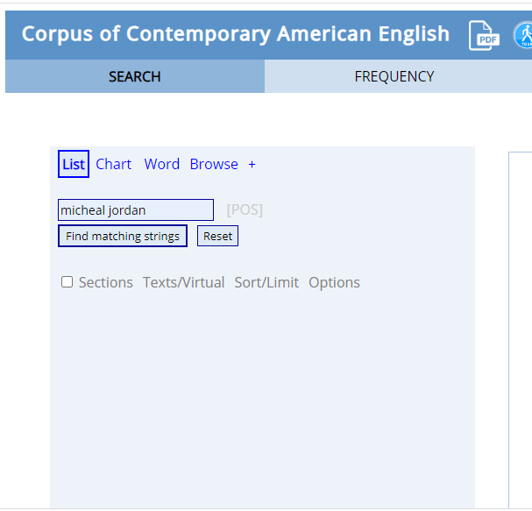

Frequency

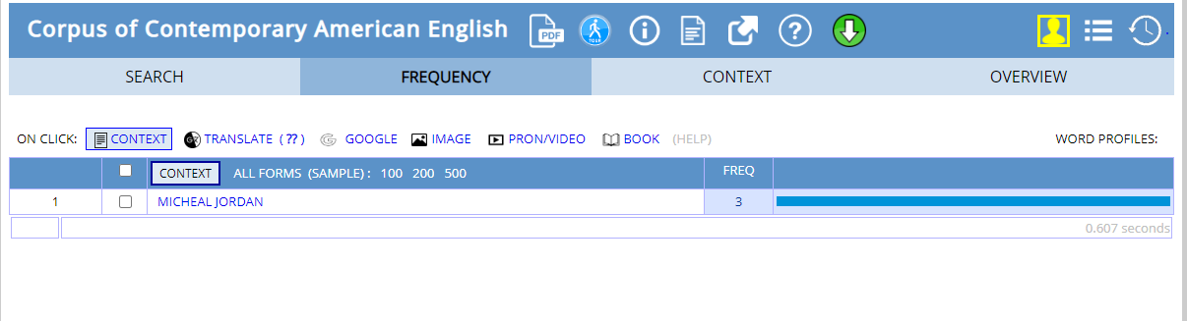

Context

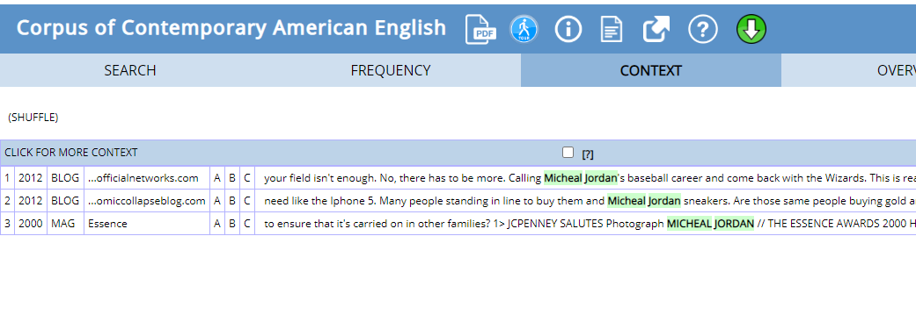

Searching frequency by section<in Chart function>

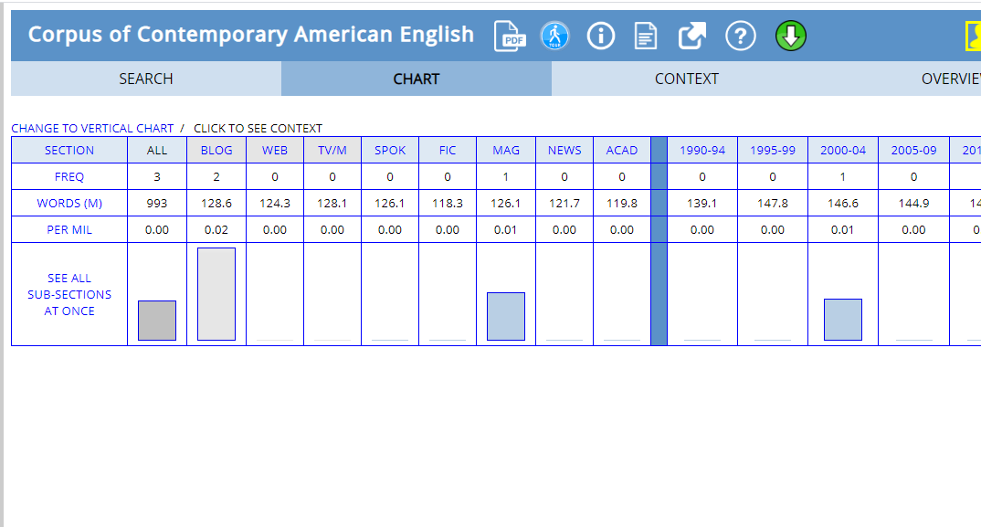

Searching word

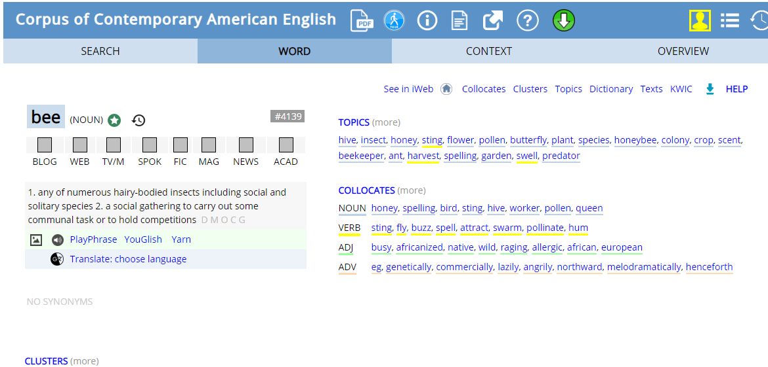

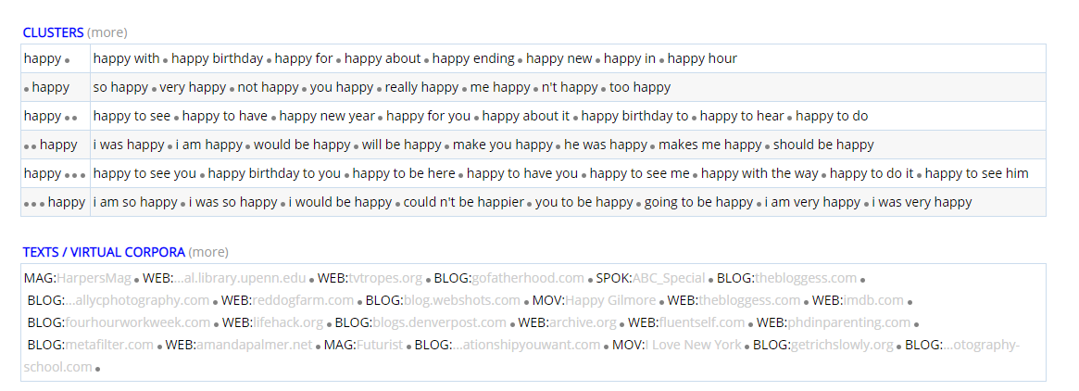

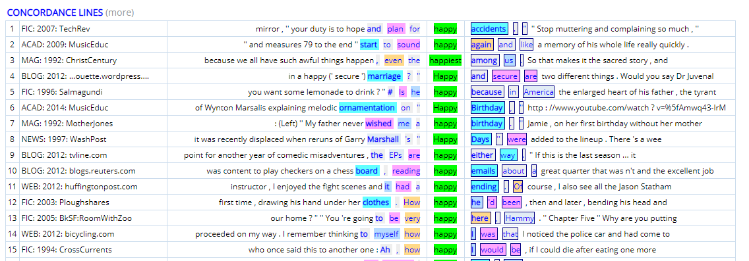

Finding collocates

